1. List and explain different PowerBi products?

* **Power BI +**[**Enterprise data warehouse**](https://www.scnsoft.com/analytics/data-warehouse/enterprise)**-** To explore and visualize corporate data stored in a centralized data storage.
* **Power BI + ERP-**To quickly optimize finance and operations related to product planning, manufacturing, sales and marketing and discover new business opportunities.
* **Power BI + CRM-**To overview customer-related data in near-real time to find top sales opportunities and better engage with customers.
* **Power BI + HRMS-**To make data-driven HR decisions for attracting and managing employees, increasing employee productivity, and creating a quality work environment.
* **Power BI + IoT device management system-**To get insight (including real-time) into the functioning of connected products, machinery, buildings, medical devices, etc. to discover new optimization opportunities, etc.

2.What limitations of Excel, Microsoft solved by PowerBi?

**Excel** has limitations in the amount of data it can work with. In contrast, Power BI can handle much larger amounts of data. Power BI can connect to a large number of data sources, while Excel's **connectivity capacity is limited**. Also, unlike Excel, Power BI can be easily used from mobile devices.

3.Explain Power Query?

With Power Query (known as Get & Transform in Excel), you can import or connect to external data, and then *shape* that data, for example remove a column, change a data type, or merge tables, in ways that meet your needs. Then, you can load your query into Excel to create charts and reports. Periodically, you can refresh the data to make it up to date. Power Query is available on three Excel applications, Excel for Windows, Excel for Mac and Excel for the Web.

4.Explain Power Map?

A power map lets you discover insights you might not see in traditional two-dimensional (2-D) tables and charts.

With Power Map, you can plot geographic and temporal data on a 3-D globe or custom map, show it over time, and create visual tours you can share with other people. You’ll want to use Power Map to:

* **Map data**    Plot more than a million rows of data visually on Bing maps in 3-D format from an Excel table or Data Model in Excel.
* **Discover insights**    Gain new understandings by viewing your data in geographic space and seeing time-stamped data change over time.
* **Share stories**    Capture screenshots and build cinematic, guided video tours you can share broadly, engaging audiences like never before. Or export tours to video and share them that way as well.

5.How power Bi eliminated the need to host SharePoint Server on premises?

[SharePoint](https://products.office.com/sharepoint/collaboration) is an important part of how many organizations organize and distribute BI content to users. In recognition of how important this approach is, we’ve invested in modernizing and creating deeper integrations with SharePoint. Over the last year, the [Power BI web part for SharePoint Online](https://docs.microsoft.com/power-bi/service-embed-report-spo) and an updated [Reporting Services Report Viewer web part](https://blogs.msdn.microsoft.com/sqlrsteamblog/2017/09/22/embed-paginated-reports-into-sharepoint-using-the-report-viewer-web-part/) for SharePoint on-premises. Customers like the flexibility this gives them to build highly-customized SharePoint experiences using their BI content

Now, customers can use [Power BI](https://powerbi.microsoft.com/) and optionally integrate their Power BI content into SharePoint 2019 and SharePoint Online, using either Power BI or Power BI Report Server. The experience in Power BI better than ever by:

· **Adding support for all major report types across both platforms**. The first public preview of Paginated (RDL) reports in Power BI Premium, giving customers full support for Paginated Reports, Power BI Reports and Excel Workbooks in Power BI.

· **Providing easier ways to report on your data in SharePoint.** The new functionality to make easier than ever to start visualizing your Excel tables and CSV files stored in SharePoint Online in Power BI.

Additionally, for Power BI Report Server, some new features that already exist in Power BI, but were previously available only through SharePoint integration for on-premises deployments. These include –

· **Power Pivot Scheduled Data Refresh.**  Thesupport for Excel Workbooks in Power BI Report Server in October 2017, including the hosting and viewing of Excel Workbooks containing data models. We’ll be expanding this support to include scheduled data refresh of these workbooks.

· **Modern Authentication support.**Security considerations are a key part of any BI deployment strategy, and many customers used SharePoint to handle [claims-based authentication scenarios](https://docs.microsoft.com/en-us/sharepoint/dev/general-development/claims-based-identity-in-sharepoint) for their users. The native support for ADFS/AAD authentication to Power BI Report Server in an upcoming release.

6.Explain the updates done in Power Bi Service (power BI 2.0) as compared to older version?

* **The format pane gets a makeover-** Power BI has changed the design of its format pane. The Power BI team has listened to their users feedback and redesigned the look and feel of the format pane to optimise the user experience and make creation easier.  
    
  The new design does not only **replace the format tab icon**, but also includes a descriptive caption to make it easier for users to find. The new Power BI format pane looks like this:

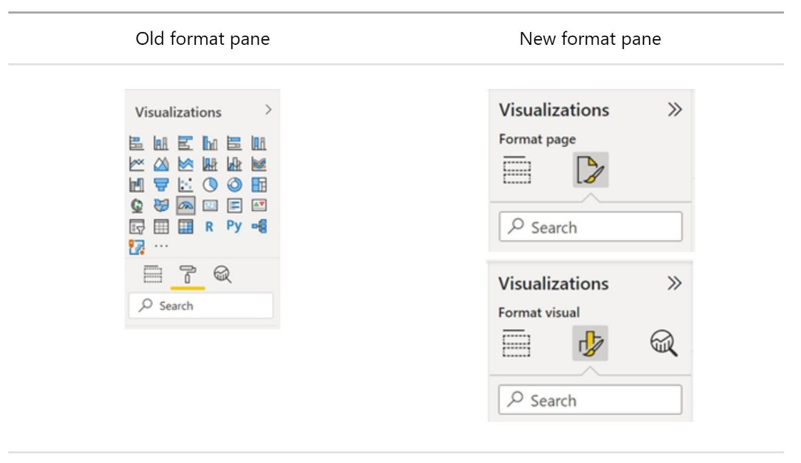

**The new Power BI format pane**

As we can see in the picture, **the visualization types gallery has been moved to the "Build" tab** in response to the limited space in the format pane. Also, **the formatting cards are now divided into two categories: visual specific and general settings**. Visual specific settings include those cards that apply to the type of visual you are currently working with.

Undoubtedly, one of the great improvements of the new formatting panel is that **it gets rid of the two scrollbars**. From now on, when we expand cards and subcategories, we will have a single scrollbar.

On the other hand, default settings can now be automatically reverted in the new format pane button.

* **Two new navigators: Page and bookmark navigators-**

Prior to the new update, users who wanted to set a customer page or bookmark navigation experience had to set up each individual button for every page or bookmark. Power BI solves this problem with **two new navigators: the page navigator and the bookmark navigator** which make it easier to create personalized navigation experiences.

Finally, the new pane allows you to **view hidden dynamic cards** and to easily switch between updating the settings for all series or for a particular series without having to scroll.

* **New dashboard visual and new visuals available in the AppSource-**

Power BI has designed **a new dashboard visual that can be added to Power BI reports** to help companies integrate business goals, performance indicators, [KPI](https://blog.bismart.com/en/what-is-a-kpi-examples-types-of-kpis)and dashboards into Power Bi Reports.

This new visual allows users to **easily integrate a dashboard into a report**as well as update their business goals. In addition, goals can be created in Power BI Desktop and dashboards can be customized to fit the design of the report.

##### New data connectors - Power BI extends its connectivity with new data connectors and by updating some of the existing connectors.

##### The new Power BI data connectors are:

**Azure Synapse Analytics**: The Azure Synapse Analytics Workspace Connector (Beta) is now available in preview mode.

**Google Sheets**: This connector received the most votes in the Power BI user forum. Microsoft has not kept its users waiting and the new connector with Google Sheets is now available.

**Data Sharing**: Finally, Power BI has launched a new connector that allows users to connect to any Delta Sharing server.

Updated connectors:

**Google Big Query**: The performance of the Google Big Query connector is improved by reducing the metadata calls required to load the browser experience. This reduces the loading time of the browser experience.

**Cognize Data Fusion**: Previous issues related to customized queries, login to the organization’s account and aggregation of time series when using tags containing special characters have been fixed.

**Dermis Cloud**: The connector has been updated to allow users to connect to regions in Dermis Cloud.

##### 

##### Choose your workspace

##### With the new version, once users have created a report's visuals they can choose the workspace where they want to save the report. This increases the capabilities of shared datasets, as users now have the ability to save reports created online in a different workspace from the workspace where the original dataset is located.

##### Permission for data objectives –

##### Data governance is a fundamental aspect for organizations when working with Power BI. The platform's data governance options are limited, but have now been extended by the new possibility to set goal level user permissions.  However, data governance remains an unfinished task for the platform. At Bismart we have our own data governance solutions specifically for Power BI: Power BI Viewer and Power BI Analytics.